 **Janakantha TraVels**

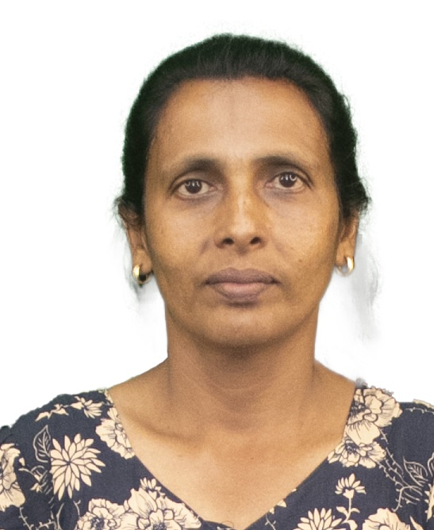

*MANPOWER AGENCY*

*LABOUR LICENSE 2781*

469/8, Palihena Building, Kaduwela. Tel: +94112579771

Email:amilasampath72@gmail.com

***APPLICATION FOR EMPLOYMENT PASSPORT DETAILS***

|  |  |  |  |
| --- | --- | --- | --- |
| **REF.NO.** | **N2084** | **NUMBER** | **N11069959** |
| **POST APPLIED FOR** | **HOUSE MAID** | **DATE OF ISSUE** | **29/12/2023** |
| **MONTHLY SALARY** | **120 KD** | **PLACE OF ISSUE** | **COLOMBO** |
| **CONTACT PERIOD** | **02 YRS** | **DATE OF EXP.** | **29/12/2033** |

***NAME IN FULL: MIRISSAGE CHANDRANI FERNANDO***

***DETAIL OF APPLICANT***

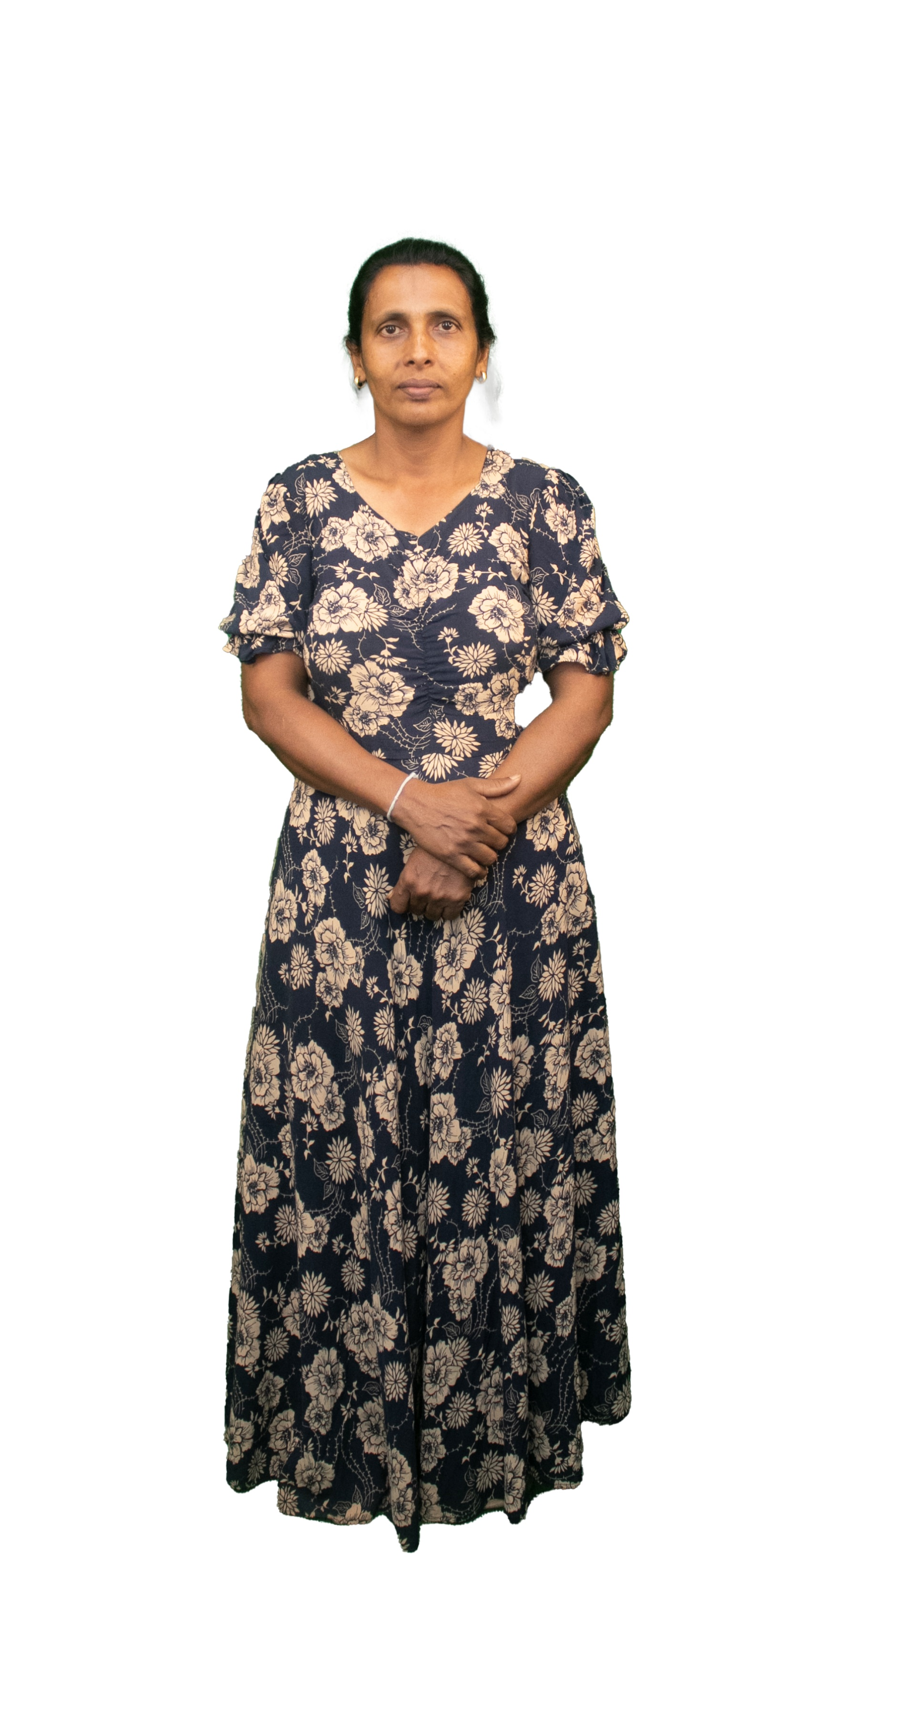

|  |
| --- |
| **NATIONALITY : SRI LANKAN** |
| **RELIGION : CHRISTIAN** |
| **DATE OF BIRTH : 16/11/1978** |
| **AGE : 44YRS** |
| **PLACE OF BIRTH : KALUTARA** |
| **MARITAL STATUS : MARRIED** |
| **CHILDREN : 03** |
| **WEIGHT : 50KG** |
| **HEIGHT : 5.3** |
| **COMPLEXION : GOOD** |
| **EDUCATIONAL QUALIFICATION : O/L** |

***KNOWLEDGE OF LANGUAGES***

|  |  |  |
| --- | --- | --- |
|  | **ENGLISH** | **ARABIC** |
| **READING** |  |  |
| **WRITING** |  |  |
| **SPEAKING** |  |  |

***PREVIOUS EMPLOYMENT ABROAD***

|  |  |
| --- | --- |
| **COUNTRY** |  |
| **PERIOD(YRS)** |  |

***JOB STATUS & ABILITY***

|  |  |
| --- | --- |
| **COOKING** | **OK - HELPER** |
| **CLEANING** | **OK** |
| **BABY SITTING** | **OK** |
| **WASHING** | **OK** |

***REMARKS: SHE IS FIRST TIME (+94760033965 ) (+94711873385 )***

**(2023 / 01 / 02 )**

