 **Janakantha TraVels**

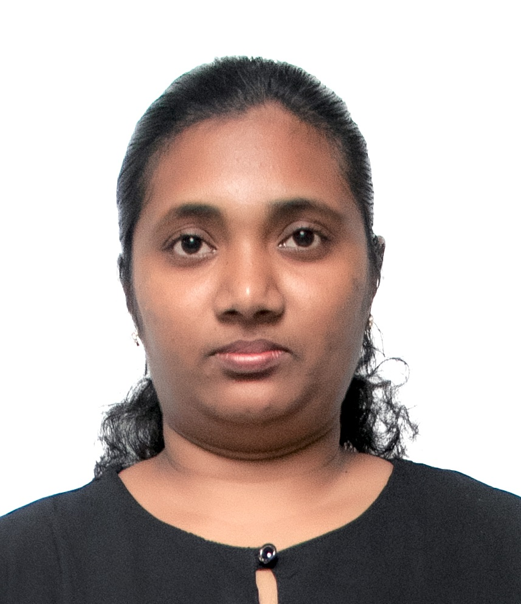

*MANPOWER AGENCY*

*LABOUR LICENSE 2781*

469/8, Palihena Building, Kaduwela. Tel: +94112579771

Email:amilasampath72@gmail.com

***APPLICATION FOR EMPLOYMENT PASSPORT DETAILS***

|  |  |  |  |
| --- | --- | --- | --- |
| **REF.NO.** | **N1327** | **NUMBER** | **N10702361** |
| **POST APPLIED FOR** | **HOUSE MAID** | **DATE OF ISSUE** | **04/07/2023** |
| **MONTHLY SALARY** | **120 KD** | **PLACE OF ISSUE** | **COLOMBO** |
| **CONTACT PERIOD** | **02 YRS** | **DATE OF EXP.** | **04/07/2033** |

***NAME IN FULL: ELLAGE NOHOTH LIYANAGE CHAPA NISHADINI KUMUDU KUMARI***

***DETAIL OF APPLICANT***

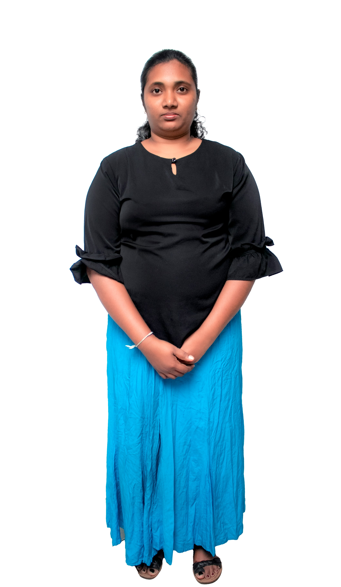

|  |
| --- |
| **NATIONALITY : SRI LANKAN** |
| **RELIGION : CHRISTIAN** |
| **DATE OF BIRTH : 10/06/1993** |
| **AGE : 30YRS** |
| **PLACE OF BIRTH : COLOMBO** |
| **MARITAL STATUS : MARRIED** |
| **CHILDREN : 03** |
| **WEIGHT : 65KG** |
| **HEIGHT : 5.4** |
| **COMPLEXION : GOOD** |
| **EDUCATIONAL QUALIFICATION : O/L** |

***KNOWLEDGE OF LANGUAGES***

|  |  |  |
| --- | --- | --- |
|  | **ENGLISH** | **ARABIC** |
| **READING** |  |  |
| **WRITING** |  |  |
| **SPEAKING** | **NORMAL** |  |

***JOB STATUS & ABILITY***

|  |  |
| --- | --- |
| **COOKING** | **OK - HELPER** |
| **CLEANING** | **OK** |
| **BABY SITTING** | **OK** |
| **WASHING** | **OK** |

***REMARKS: SHE IS FIRST TIME (+94766642726 ) (+94764037185 )***

**(2023 / 07 / 07 )**

