 **Janakantha TraVels**

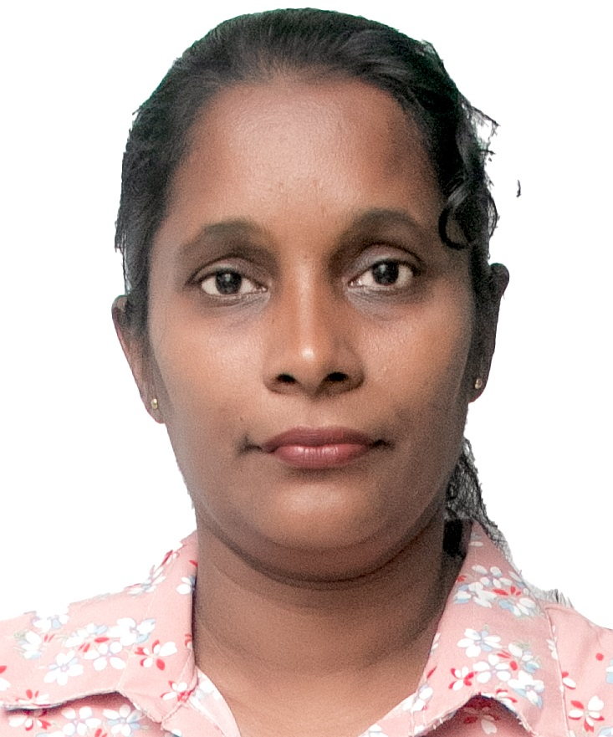

*MANPOWER AGENCY*

*LABOUR LICENSE 2781*

469/8, Palihena Building, Kaduwela. Tel: +94112579771

Email:amilasampath72@gmail.com

***APPLICATION FOR EMPLOYMENT PASSPORT DETAILS***

|  |  |  |  |
| --- | --- | --- | --- |
| **REF.NO.** | **N1700** | **NUMBER** | **N9771945** |
| **POST APPLIED FOR** | **HOUSE MAID** | **DATE OF ISSUE** | **05/08/2022** |
| **MONTHLY SALARY** | **120 KD** | **PLACE OF ISSUE** | **COLOMBO** |
| **CONTACT PERIOD** | **02 YRS** | **DATE OF EXP.** | **05/08/2032** |

***NAME IN FULL: NANAYAKKARA WASAN HAPUGALAGE INOKA UDAYANGANI***

***DETAIL OF APPLICANT***

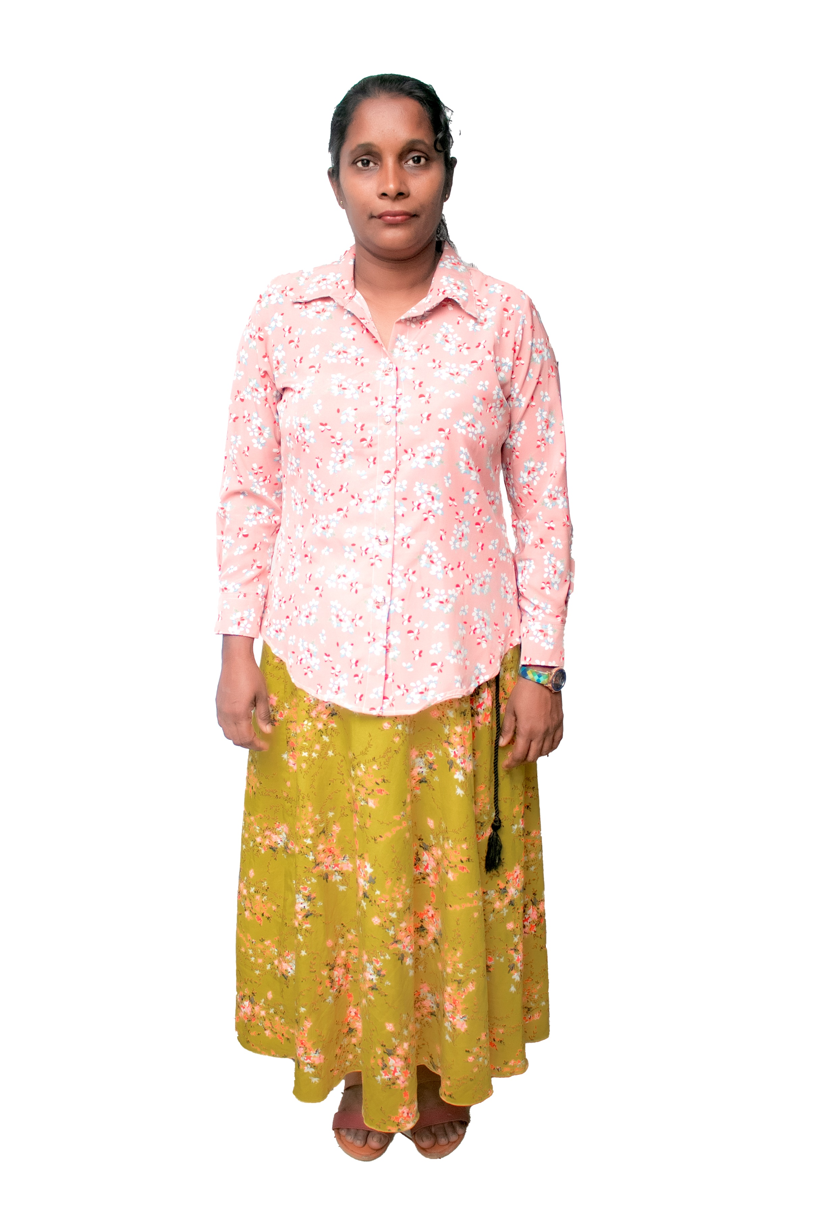

|  |
| --- |
| **NATIONALITY : SRI LANKAN** |
| **RELIGION : CHRISTIAN** |
| **DATE OF BIRTH : 21/08/1980** |
| **AGE : 43YRS** |
| **PLACE OF BIRTH : GALLE** |
| **MARITAL STATUS : MARRIED** |
| **CHILDREN : 03** |
| **WEIGHT : 60KG** |
| **HEIGHT : 5.6** |
| **COMPLEXION : GOOD** |
| **EDUCATIONAL QUALIFICATION : O/L** |

***KNOWLEDGE OF LANGUAGES***

|  |  |  |
| --- | --- | --- |
|  | **ENGLISH** | **ARABIC** |
| **READING** | **NO** | **NO** |
| **WRITING** | **NO** | **NO** |
| **SPEAKING** | **OK** | **NO** |

|  |  |
| --- | --- |
| **COOKING** | **OK - HELPER** |
| **CLEANING** | **OK** |
| **BABY SITTING** | **OK** |
| **WASHING** | **OK** |

***REMARKS: SHE IS FIRST TIME (+94775069134 ) (+94778149927 )***

**(2023 / 10 / 28 )**

