 **Janakantha TraVels**

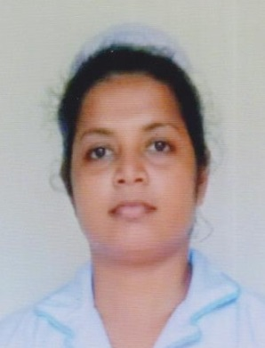

*MANPOWER AGENCY*

*LABOUR LICENSE 2781*

469/8, Palihena Building, Kaduwela. Tel: +94112579771

Email:amilasampath72@gmail.com

***APPLICATION FOR EMPLOYMENT PASSPORT DETAILS***

|  |  |  |  |
| --- | --- | --- | --- |
| **REF.NO.** | **N1184** | **NUMBER** | **N9181627** |
| **POST APPLIED FOR** | **NURSE** | **DATE OF ISSUE** | **02/12/2021** |
| **MONTHLY SALARY** | **180 KD** | **PLACE OF ISSUE** | **COLOMBO** |
| **CONTACT PERIOD** | **02 YRS** | **DATE OF EXP.** | **02/12/2031** |

***NAME IN FULL: JAYASINGHE YASHIKA RASADARI***

***DETAIL OF APPLICANT***

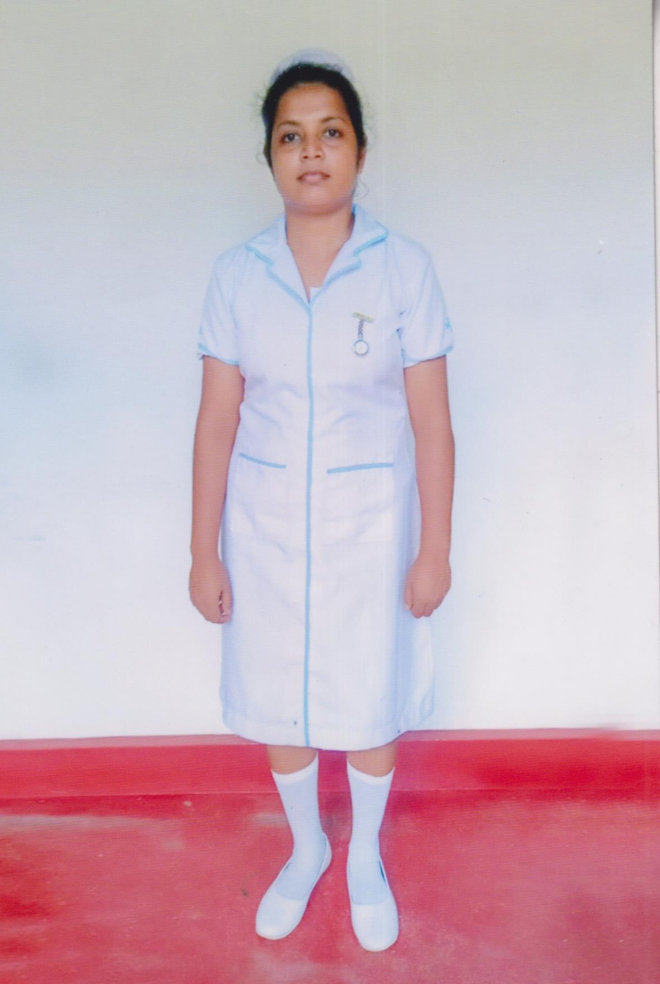

|  |
| --- |
| **NATIONALITY : SRI LANKAN** |
| **RELIGION : CHRISTIAN** |
| **DATE OF BIRTH : 01/08/1994** |
| **AGE : 28YRS** |
| **PLACE OF BIRTH : RAGAMA** |
| **MARITAL STATUS : UNMARRIED** |
| **CHILDREN : 00** |
| **WEIGHT : 58KG** |
| **HEIGHT : 5.4** |
| **COMPLEXION : GOOD** |
| **EDUCATIONAL QUALIFICATION : A/L** |

***KNOWLEDGE OF LANGUAGES***

|  |  |  |
| --- | --- | --- |
|  | **ENGLISH** | **ARABIC** |
| **READING** | **OK** | **FAIR** |
| **WRITING** | **OK** | **FAIR** |
| **SPEAKING** | **OK** | **FAIR** |

***PREVIOUS EMPLOYMENT ABROAD***

|  |  |
| --- | --- |
| **COUNTRY** | **SRI LANKA** |
| **PERIOD(YRS)** | **04** |

***JOB STATUS & ABILITY***

|  |  |
| --- | --- |
| **NURSING** | **OK** |
| **CARE GIVING** | **OK** |

***REMARKS: SHE IS FIRST TIME  (+94789493981 ) (+94782866477 )***

