 **Janakantha TraVels**

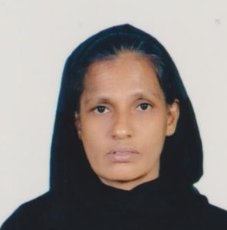

*MANPOWER AGENCY*

*LABOUR LICENSE 2781*

469/8, Palihena Building, Kaduwela. Tel: +94112579771

Email:amilasampath72@gmail.com

***APPLICATION FOR EMPLOYMENT PASSPORT DETAILS***

|  |  |  |  |
| --- | --- | --- | --- |
| **REF.NO.** | **N1107** | **NUMBER** | **N10539291** |
| **POST APPLIED FOR** | **HOUSE MAID** | **DATE OF ISSUE** | **08/05/2023** |
| **MONTHLY SALARY** | **120 BD** | **PLACE OF ISSUE** | **COLOMBO** |
| **CONTACT PERIOD** | **02 YRS** | **DATE OF EXP.** | **08/05/2033** |

***NAME IN FULL: SAMMU HANDI SUNITHA***

***DETAIL OF APPLICANT***

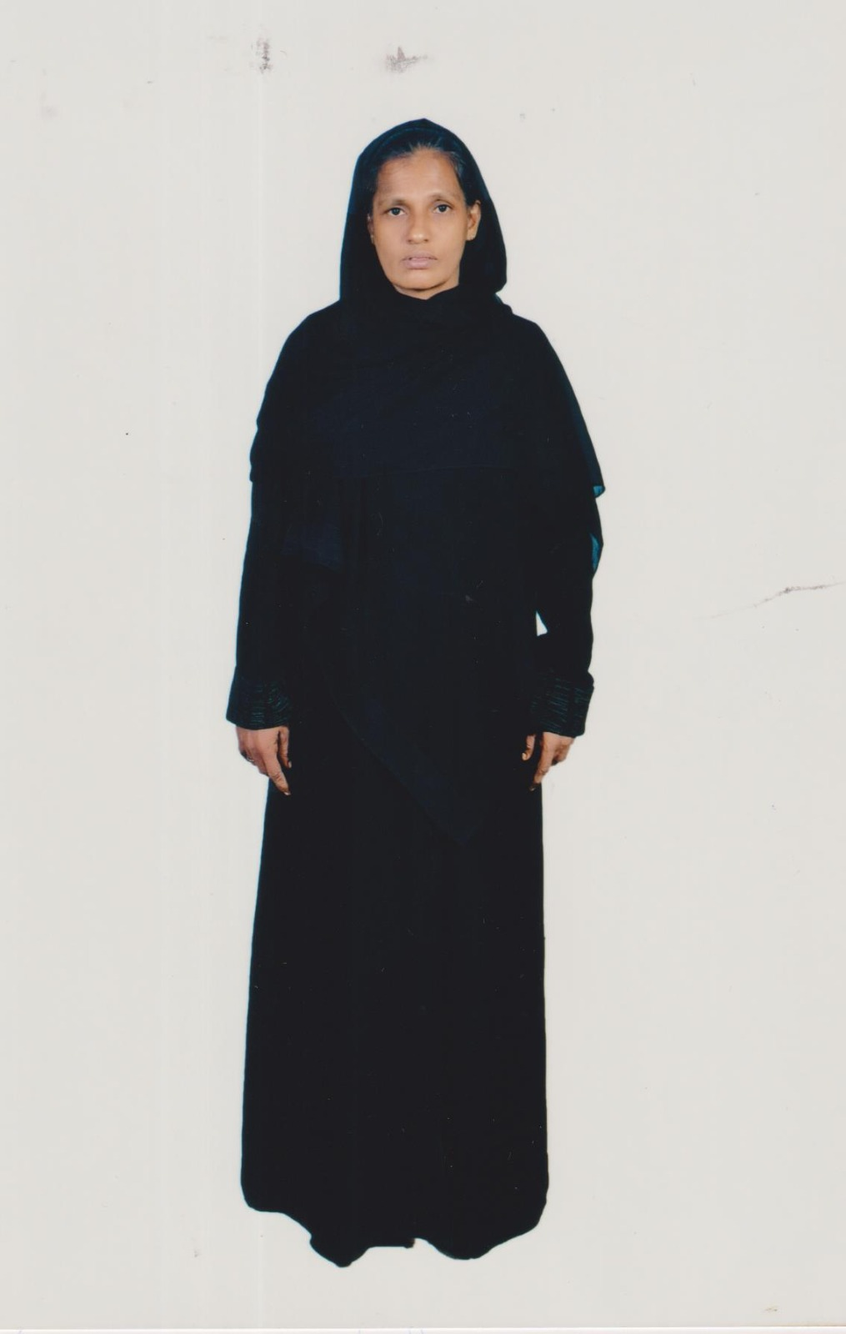

|  |
| --- |
| **NATIONALITY : SRI LANKAN** |
| **RELIGION : CHRISTIAN** |
| **DATE OF BIRTH : 02/08/1977** |
| **AGE : 45YRS** |
| **PLACE OF BIRTH : GALLE** |
| **MARITAL STATUS : MARRIED** |
| **CHILDREN : 05** |
| **WEIGHT : 60KG** |
| **HEIGHT : 5.4** |
| **COMPLEXION : GOOD** |
| **EDUCATIONAL QUALIFICATION : GRADE 10** |

***JOB STATUS & ABILITY***

|  |  |
| --- | --- |
| **COOKING** | **OK - HELPER** |
| **CLEANING** | **OK** |
| **BABY SITTING** | **OK** |
| **WASHING** | **OK** |

***REMARKS: SHE IS FIRST TIME (+94770399552 ) (+94718881934 ) (+94766614207 )***

