 **Janakantha TraVels**

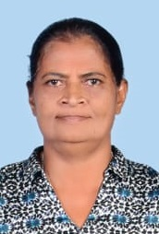

*MANPOWER AGENCY*

*LABOUR LICENSE 2781*

469/8, Palihena Building, Kaduwela. Tel: +94112579771

Email:amilasampath72@gmail.com

***APPLICATION FOR EMPLOYMENT PASSPORT DETAILS***

|  |  |  |  |
| --- | --- | --- | --- |
| **REF.NO.** | **N1371** | **NUMBER** | **N10684345** |
| **POST APPLIED FOR** | **HOUSE MAID** | **DATE OF ISSUE** | **22/06/2023** |
| **MONTHLY SALARY** | **130 KD** | **PLACE OF ISSUE** | **COLOMBO** |
| **CONTACT PERIOD** | **02 YRS** | **DATE OF EXP.** | **22/06/2033** |

***NAME IN FULL: BADDEGAMA GEEGANAGE DONA INDRANI SELIN DE SILVA***

***DETAIL OF APPLICANT***

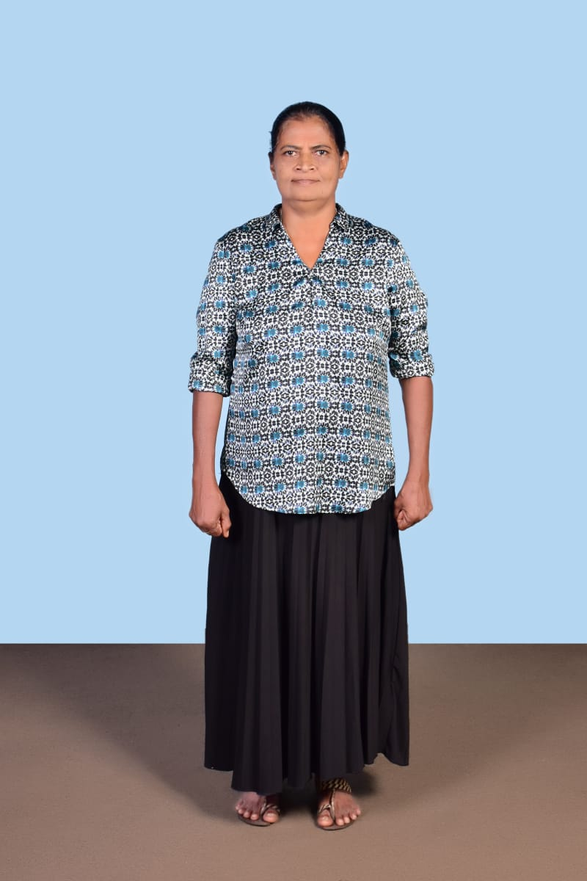

|  |
| --- |
| **NATIONALITY : SRI LANKAN** |
| **RELIGION : CHRISTIAN** |
| **DATE OF BIRTH : 22/04/1964** |
| **AGE : 59YRS** |
| **PLACE OF BIRTH : COLOMBO** |
| **MARITAL STATUS : MARRIED** |
| **CHILDREN : 02** |
| **WEIGHT : 62KG** |
| **HEIGHT : 5.5** |
| **COMPLEXION : GOOD** |
| **EDUCATIONAL QUALIFICATION : GRADE 10** |

***KNOWLEDGE OF LANGUAGES***

|  |  |  |
| --- | --- | --- |
|  | **ENGLISH** | **ARABIC** |
| **READING** | **FAIR** | **FAIR** |
| **WRITING** | **FAIR** | **FAIR** |
| **SPEAKING** | **FAIR** | **OK** |

***PREVIOUS EMPLOYMENT ABROAD***

|  |  |
| --- | --- |
| **KUWAIT** | **05 ALLAROUNDER** |
| **SAUDI** | **02 AS A COOK** |
| **DUBAI** | **02 AS A COOK** |

***JOB STATUS & ABILITY***

|  |  |
| --- | --- |
| **COOKING** | **OK** |
| **CLEANING** | **OK** |
| **BABY SITTING** | **OK** |
| **WASHING** | **OK** |

***REMARKS: SHE HAS EXPERIENCES (+94768215275 ) (+94332217014 )***

**(2023 / 07 / 22**

