 **Janakantha TraVels**



*MANPOWER AGENCY*

*LABOUR LICENSE 2781*

469/8, Palihena Building, Kaduwela. Tel: +94112579771

Email:amilasampath72@gmail.com

***APPLICATION FOR EMPLOYMENT PASSPORT DETAILS***

|  |  |  |  |
| --- | --- | --- | --- |
| **REF.NO.** | **N1137** | **NUMBER** | **N10556830** |
| **POST APPLIED FOR** | **HOUSE MAID** | **DATE OF ISSUE** | **15/05/2023** |
| **MONTHLY SALARY** | **120 KD** | **PLACE OF ISSUE** | **COLOMBO** |
| **CONTACT PERIOD** | **02 YRS** | **DATE OF EXP.** | **15/05/2033** |

***NAME IN FULL: KODIKARA ARACHCHIGE RENUKA***

***DETAIL OF APPLICANT***

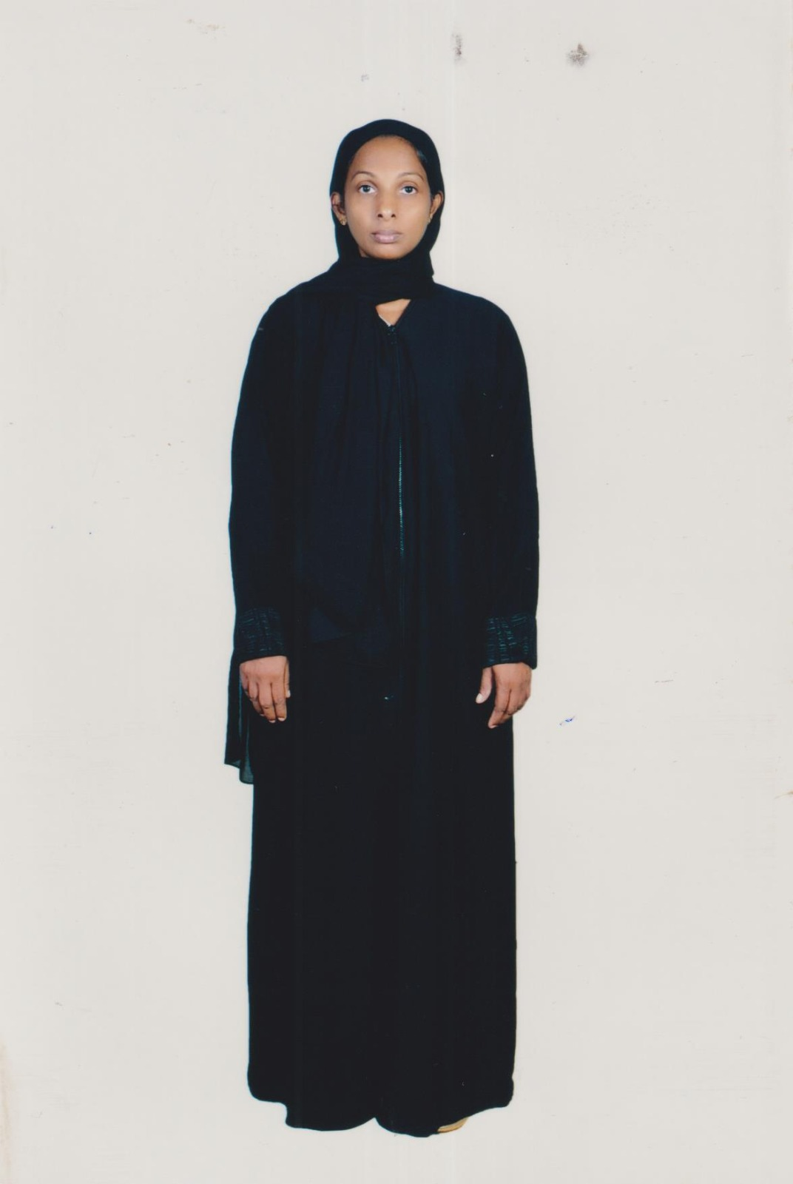

|  |
| --- |
| **NATIONALITY : SRI LANKAN** |
| **RELIGION : CHRISTIAN** |
| **DATE OF BIRTH : 07/11/1979** |
| **AGE : 43YRS** |
| **PLACE OF BIRTH : COLOMBO** |
| **MARITAL STATUS : MARRIED** |
| **CHILDREN : 01** |
| **WEIGHT : 52KG** |
| **HEIGHT : 5.2** |
| **COMPLEXION : GOOD** |
| **EDUCATIONAL QUALIFICATION : GRADE 10** |

***KNOWLEDGE OF LANGUAGES***

|  |  |  |
| --- | --- | --- |
|  | **ENGLISH** | **ARABIC** |
| **READING** | **FAIR** | **X** |
| **WRITING** | **FAIR** | **X** |
| **SPEAKING** | **NORMAL** | **X** |

***PREVIOUS EMPLOYMENT ABROAD***

|  |  |
| --- | --- |
| **COUNTRY** |  |
| **PERIOD(YRS)** |  |

***JOB STATUS & ABILITY***

|  |  |
| --- | --- |
| **COOKING** | **OK - HELPER** |
| **CLEANING** | **OK** |
| **BABY SITTING** | **OK** |
| **WASHING** | **OK** |

***REMARKS: SHE IS FIRST TIME  (+94756504112 ) (+94761181747 )***

