 Janakantha TraVels

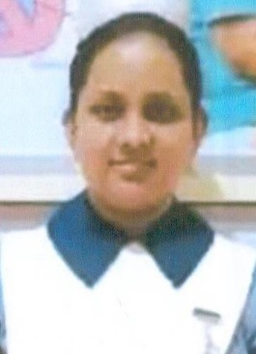

*MANPOWER AGENCY*

*LABOUR LICENSE 2781*

469/8, Palihena Building, Kaduwela. Tel: +94112579771

Email:amilasampath72@gmail.com

***APPLICATION FOR EMPLOYMENT PASSPORT DETAILS***

|  |  |  |  |
| --- | --- | --- | --- |
| **REF.NO.** | **N552** | **NUMBER** | **N7605919** |
| **POST APPLIED FOR** | **NURSE** | **DATE OF ISSUE** | **09/11/2017** |
| **MONTHLY SALARY** | **180KD** | **PLACE OF ISSUE** | **COLOMBO** |
| **CONTACT PERIOD** | **02 YRS** | **DATE OF EXP.** | **09/11/2027** |

***NAME IN FULL: GAMA ATHI ARACHCHILAGE UMESHA THAMALI***

***DETAIL OF APPLICANT***

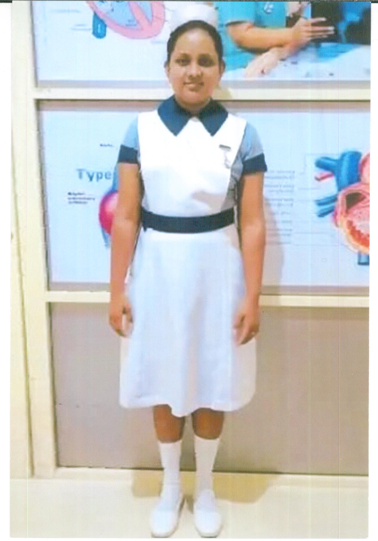

|  |
| --- |
| **NATIONALITY : SRI LANKAN** |
| **RELIGION : CHRISTIAN** |
| **DATE OF BIRTH : 17/05/1996** |
| **AGE : 25YRS** |
| **PLACE OF BIRTH :COLOMBO** |
| **MARITAL STATUS :UNMARRIED** |
| **CHILDREN : 00** |
| **WEIGHT : 65KG** |
| **HEIGHT : 5 '2’’** |
| **COMPLEXION : GOOD** |
| **EDUCATIONAL QUALIFICATION : GREAD 10** |

***KNOWLEDGE OF LANGUAGES***

|  |  |  |
| --- | --- | --- |
|  | **ENGLISH** | **ARABIC** |
| **READING** | **FAIR** | X |
| **WRITING** | **FAIR** | X |
| **SPEAKING** | **BASIC** | **BASIC** |

***PREVIOUS EMPLOYMENT EXPERIENCES (YRS)***

|  |  |
| --- | --- |
| **UAE** | **2017 – 2018 ONE YEARS AS A NURSE** |
| **SRI LANKA** | **IN SERVICE SINCE 2020 AS A NURSE** |

***JOB STATUS & ABILITY***

|  |  |
| --- | --- |
| **NURSING** | **OK** |
| **CARE GIVING** | **OK** |
|  |  |
|  |  |

***REMARKS: SHE HAS EXPERIENCES.NURSE (+94772216957)***

