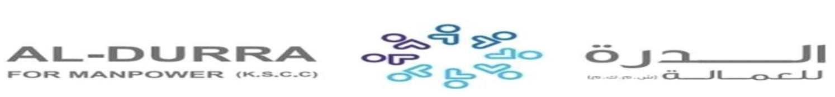

|  |  |  |  |  |  |  |  |  |
| --- | --- | --- | --- | --- | --- | --- | --- | --- |
| **REF. NO.:** T1-DVO-00000018 | | | | **(REMARKS)** SKILLS: | |  |  | |
|  |  | |  |
| **APPLIED FOR:**  DOMESTIC HELPER | | | |
| **SALARY:** | | | |
| **FULL NAME:** ELIZABETH BALSA BESTAS | | | | | |  | **DETAILS OF PASSPORT** | |
| **NATIONALITY:** FILIPINO | | | | |  | **ال ج ن س ية** | **PASSPORT#:**P6912965B | **ال جواز رق م** |
| **MOBILE NO.:** | | | | |  | **ال هات ف رق م** | **PLACE OF ISSUE:**  DFA DAVAO | **مكان األ صدار** |
| **DATE OF BIRTH:** FEB 09, 1993 | | | | |  | **ال والد ة ت اري خ** | **DATE OF ISSUE:**  JUN 03, 2021 | **األ صدار ت اري خ** |
| **AGE:** 30  **PLACE OF BIRTH:** PARANG MAGUINDANAO | | | | |  | **ال عمرال م ي الد مكان** | **DATE OF EXPIRY:**  JUN 02, 2031 | **ت اري خاألن تهاء** |
| **RELIGION:** CHRISTIANITY - CATHOLIC | | | | |  | **ال دي ان ه** |  | |
| **MARITAL STATUS:** SINGLE | | | | |  | **ال حال ةاالج تماع ية** |
| **WEIGHT:** 50 KG | | | | |  | **ال وزن** |
| **HEIGHT:** 5'3 CM | | | | |  | **ال طول** |
| **NO. OF CHILDREN:** 0 | | | | |  | **ألط فال عدد** |
| **PREVIOUS EMPLOYMENT ABROAD**  **ل ل ع م ل ا ل س ا ب ق ه ا ل خ ب ره** | | | | | |  |
| **COUNTRY** | | **POSITION** | | |  | **YEAR** |
| SAUDI ARABIA | | DOMESTIC HELPER | | |  | 2017 - 2019 |
|  | |  | | |  |  |
|  | |  | | |  |  |
| **EDUCATIONAL QUALIFICATIONS التعليممستوى** | | | | | |  |
| PRIMARY | | | | | |  |
| **LANGUAGES** | | | | | |  |
| **ARABIC** | | WILLING TO LEARN | | | |  |
| **ENGLISH** | | FAIR | | | |  |
| **AL-DURRA CONTACT #:** | | | | | |  |

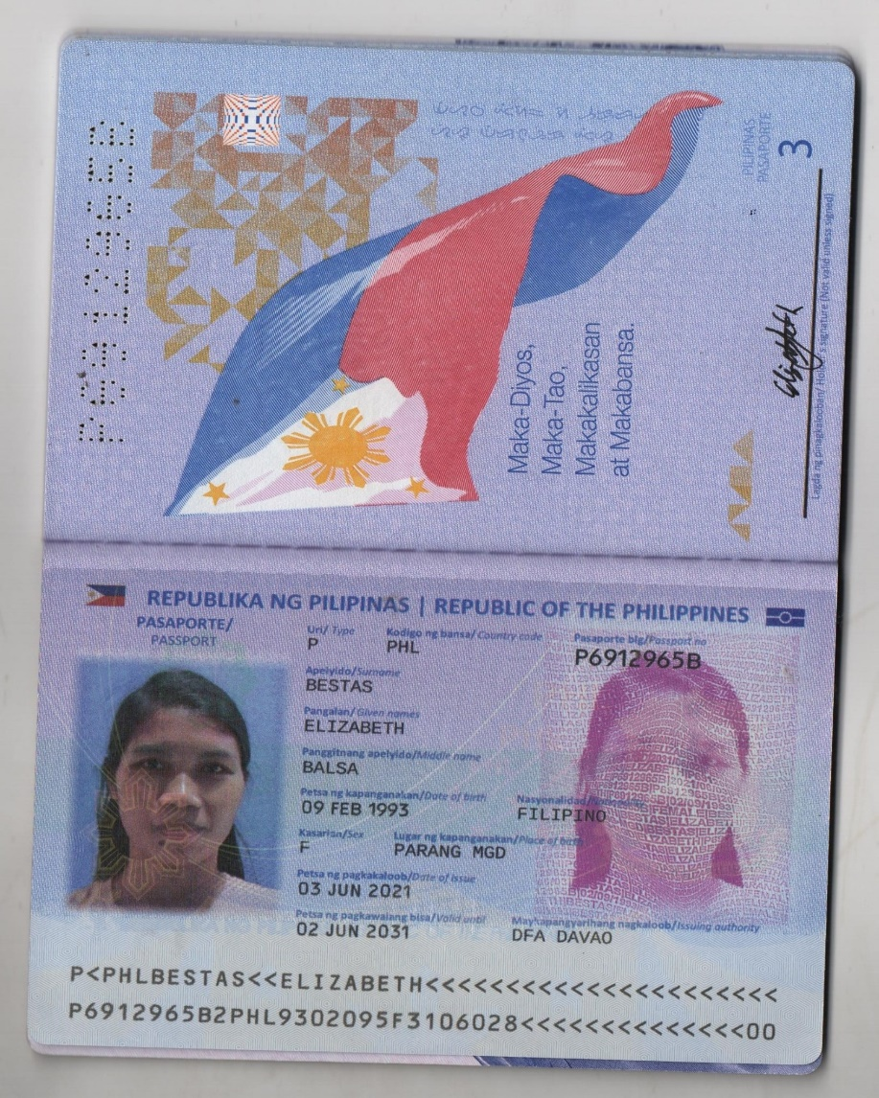PASSPORT