

|  |  |  |  |  |  |  |  |
| --- | --- | --- | --- | --- | --- | --- | --- |
| **REF. NO.:** T1-KOR-00000004 | | | | **( REMARKS )** SKILLS:  Cooking Cleaning Laundry  Ironing Car Washing Gardening  Water Plants Pet Care Babysitting  Baby Care Child Care Caring of Old-Aged  Caring of Bedridden Care of Special Child Tutoring of Children  Tutoring | | | |
|  |  | |  |
| **APPLIED FOR:**  DOMESTIC HELPER | | | |
| **SALARY:** | | | |
| **FULL NAME:** EDEN CALIBAYAN CARDOS | | | | | | **DETAILS OF PASSPORT** | |
| **NATIONALITY:** FILIPINO | | | | | **ال ج ن س ية** | **PASSPORT#:**P5714007B | **ال جواز رق م** |
| **MOBILE NO.:** | | | | | **ال هات ف رق م** | **PLACE OF ISSUE:**  PE KUWAIT | **مكان األ صدار** |
| **DATE OF BIRTH:** JAN 19, 1990 | | | | | **ال والد ة ت اري خ** | **DATE OF ISSUE:**  NOV 04, 2020 | **األ صدار ت اري خ** |
| **AGE:** 33  **PLACE OF BIRTH:** LAKE SEBU, SOUTH COTABATO | | | | | **ال عمر ال م ي الد مكان** | **DATE OF EXPIRY:**  NOV 03, 2030 | **ت اري خ األن تهاء** |
| **RELIGION:** CHRISTIANITY - CATHOLIC | | | | | **ال دي ان ه** |  | |
| **MARITAL STATUS:** SINGLE | | | | | **حال ةاالج تماع يةال** |
| **WEIGHT:** 48 KG | | | | | **ال وزن** |
| **HEIGHT:** 165 CM | | | | | **ال طول** |
| **NO. OF CHILDREN:** 1 | | | | | **ألط فال عدد** |
| **PREVIOUS EMPLOYMENT ABROAD ل ل ع م ل ا ل س ا ب ق ه ا ل خ ب ره** | | | | | |
| **COUNTRY** | | **POSITION** | | | **YEAR** |
| KUWAIT | | DOMESTIC HELPER | | | 2016 - 2022 |
|  | |  | | |  |
|  | |  | | |  |
| **EDUCATIONAL QUALIFICATIONS التعليممستوى** | | | | | |
| HIGH SCHOOL DIPLOMA | | | | | |
| **LANGUAGES** | | | | | |
| **ARABIC** | | WILLING TO LEARN | | | |
| **ENGLISH** | | GOOD | | | |
| **AL-DURRA CONTACT #:** | | | | | |

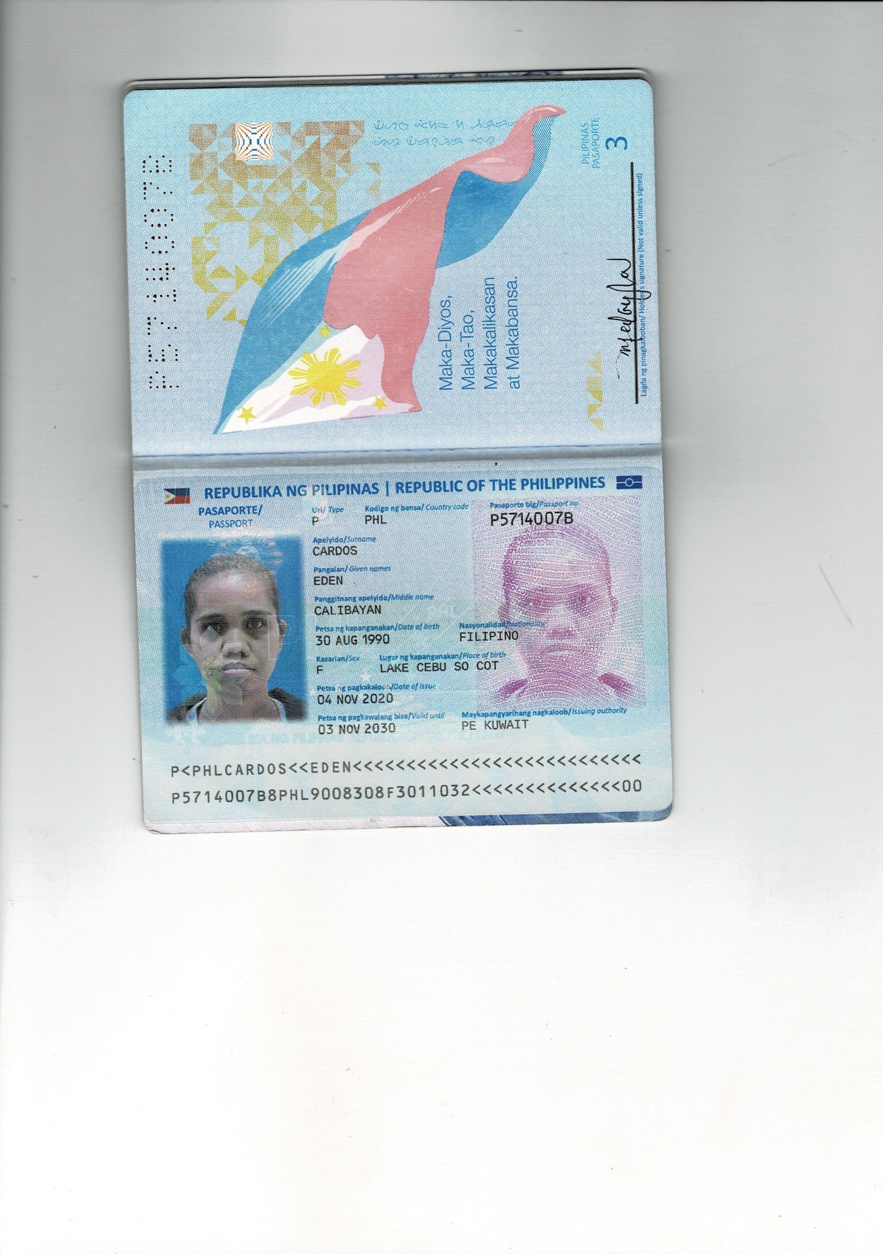PASSPORT COPY