

|  |  |  |  |  |  |  |  |
| --- | --- | --- | --- | --- | --- | --- | --- |
| **REF. NO.:** T1-TAC-00000079 | | | | **(REMARKS)** SKILLS:  CookingC  IroningB  Child Care | | leaningLaundry  abysittingBaby Care | |
|  |  | |  |
| **APPLIED FOR:**  DH | | | |
| **SALARY:**  120 KD | | | |
| **FULL NAME:** STEPHANIE JOY LACUESTA LAGUMBAYAN | | | | | | **DETAILS OF PASSPORT** | |
| **NATIONALITY:** FILIPINO | | | | | **ال ج ن س ية** | **PASSPORT#:**P2556326B | **ال جواز رق م** |
| **MOBILE NO.:** +63 935 927 9717 | | | | | **ال هات ف رق م** | **PLACE OF ISSUE:**  DFA GENERAL SANTOS | **مكان األ صدار** |
| **DATE OF BIRTH:** APR 12, 1991 | | | | | **ال والد ة ت اري خ** | **DATE OF ISSUE:**  JUL 16, 2019 | **األ صدار ت اري خ** |
| **AGE:** 31  **PLACE OF BIRTH:** ISULAN SULTAN KUDARAT | | | | | **ال عمرال م ي الد مكان** | **DATE OF EXPIRY:**  JUL 15, 2029 | **ت اري خاألن تهاء** |
| **RELIGION:** CHRISTIANITY - OTHERS | | | | | **ال دي ان ه** |  | |
| **MARITAL STATUS:** SINGLE | | | | | **ال حال ةاالج تماع ية** |
| **WEIGHT:** 60 KILOS KG | | | | | **ال وزن** |
| **HEIGHT:** 5'1 CM | | | | | **ال طول** |
| **NO. OF CHILDREN:** 0 | | | | | **ألط فال عدد** |
| **PREVIOUS EMPLOYMENT ABROAD**  **ل ل ع م ل ا ل س ا ب ق ه ا ل خ ب ره** | | | | | |
| **COUNTRY** | | **POSITION** | | | **YEAR** |
| KUWAIT | | DH | | | 2019 - 2022 |
|  | |  | | |  |
|  | |  | | |  |
| **EDUCATIONAL QUALIFICATIONS التعليممستوى** | | | | | |
| VOCATIONAL DIPLOMA / SHORT COURSE CERTIFICATE | | | | | |
| **LANGUAGES** | | | | | |
| **ARABIC** | |  | | | |
| **ENGLISH** | | FAIR | | | |
| **AL-DURRA CONTACT #:** +63 935 927 9717 | | | | | |

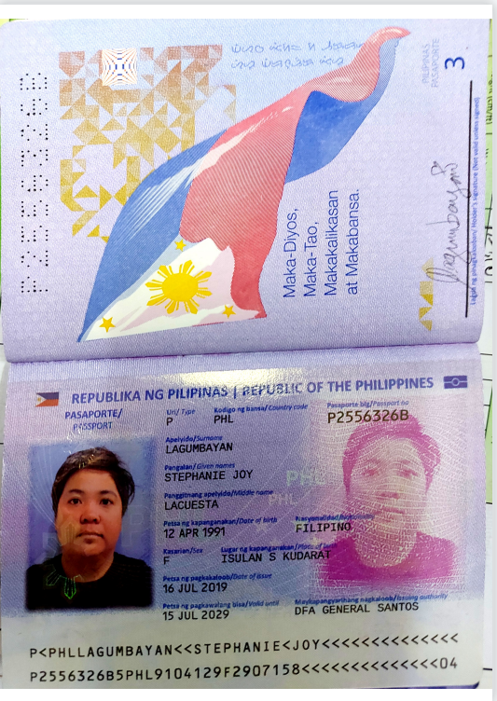PASSPORT