

|  |  |  |  |  |  |  |  |
| --- | --- | --- | --- | --- | --- | --- | --- |
| **REF. NO.:** T1-TAC-00000076 | | | | **( REMARKS )** SKILLS:  Cooking Cleaning Laundry  Ironing Babysitting Baby Care  Child Care | | | |
|  |  | |  |
| **APPLIED FOR:**  DH | | | |
| **SALARY:**  120 KD | | | |
| **FULL NAME:** RAMLA RAHIM LANDO | | | | | | **DETAILS OF PASSPORT** | |
| **NATIONALITY:** FILIPINO | | | | | **ال ج ن س ية** | **PASSPORT#:**P3472213B | **ال جواز رق م** |
| **MOBILE NO.:** +63 955 035 148 | | | | | **ال هات ف رق م** | **PLACE OF ISSUE:**  DFA COTABATO | **مكان األ صدار** |
| **DATE OF BIRTH:** JUN 02, 1991 | | | | | **ال والد ة ت اري خ** | **DATE OF ISSUE:**  OCT 08, 2019 | **األ صدار ت اري خ** |
| **AGE:** 31  **PLACE OF BIRTH:** DATU SIN SUAT MAGUINDANAO | | | | | **ال عمر ال م ي الد مكان** | **DATE OF EXPIRY:**  OCT 07, 2029 | **ت اري خ األن تهاء** |
| **RELIGION:** ISLAM | | | | | **ال دي ان ه** |  | |
| **MARITAL STATUS:** MARRIED | | | | | **حال ةاالج تماع يةال** |
| **WEIGHT:** 65 KILOS KG | | | | | **ال وزن** |
| **HEIGHT:** 5'3 CM | | | | | **ال طول** |
| **NO. OF CHILDREN:** 3 | | | | | **ألط فال عدد** |
| **PREVIOUS EMPLOYMENT ABROAD ل ل ع م ل ا ل س ا ب ق ه ا ل خ ب ره** | | | | | |
| **COUNTRY** | | **POSITION** | | | **YEAR** |
| SAUDI ARABIA | | DH | | | 2015 - 2021 |
|  | |  | | |  |
|  | |  | | |  |
| **EDUCATIONAL QUALIFICATIONS التعليممستوى** | | | | | |
| PRIMARY | | | | | |
| **LANGUAGES** | | | | | |
| **ARABIC** | | FAIR | | | |
| **ENGLISH** | | FAIR | | | |
| **AL-DURRA CONTACT #:** +63 955 035 148 | | | | | |

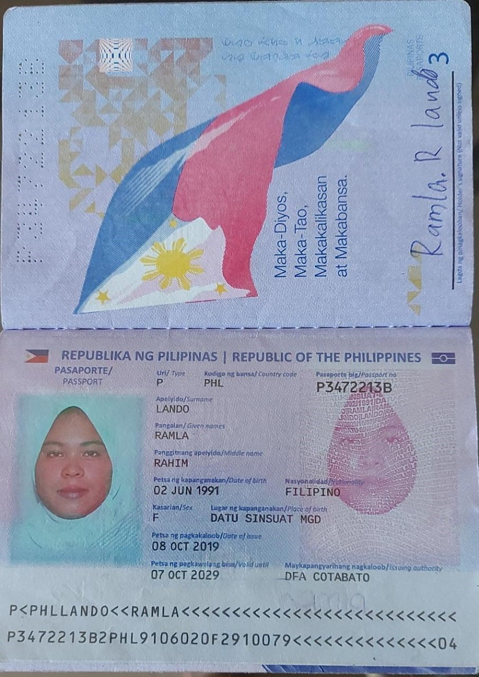PASSPORT COPY