|  |  |  |  |  |  |  |  |
| --- | --- | --- | --- | --- | --- | --- | --- |
| **REF. NO.:** T1-KOR-00000002 | | | | **(REMARKS)**  VACCINE: SKILLS:  Cleaning  Car Washing  Cycling  Child Care  Tutoring | L  G  B  C | aundryIroning  ardeningWater Plants  abysittingBaby Care  aring of Old-AgedTutoring of Children | |
|  |  | |  |
| **APPLIED FOR:**  DOMESTIC HELPER | | | |
| **SALARY:** | | | |
| **FULL NAME:** JANET SABADO ARENO | | | | |  | **DETAILS OF PASSPORT** | |
| **NATIONALITY:** FILIPINO | | | | | **ال ج ن س ية** | **PASSPORT#:**P9520934B | **ال جواز رق م** |
| **MOBILE NO.:** +63 909 763 8730 | | | | | **ال هات ف رق م** | **PLACE OF ISSUE:**  DFA NCR WEST | **مكان األ صدار** |
| **DATE OF BIRTH:** OCT 19, 1990 | | | | | **ال والد ة ت اري خ** | **DATE OF ISSUE:**  APR 06, 2022 | **األ صدار ت اري خ** |
| **AGE:** 32  **PLACE OF BIRTH:** PARANG, MAGUINDANAO | | | | | **ال عمرال م ي الد مكان** | **DATE OF EXPIRY:**  APR 05, 2032 | **ت اري خاألن تهاء** |
| **RELIGION:** CHRISTIANITY - OTHERS | | | | | **ال دي ان ه** |  | |
| **MARITAL STATUS:** SINGLE | | | | | **ال حال ةاالج تماع ية** |
| **WEIGHT:** 59 KG | | | | | **ال وزن** |
| **HEIGHT:** 157 CM | | | | | **ال طول** |
| **NO. OF CHILDREN:** 1 | | | | | **ألط فال عدد** |
| **PREVIOUS EMPLOYMENT ABROAD**  **ل ل ع م ل ا ل س ا ب ق ه ا ل خ ب ره** | | | | |  |
| **COUNTRY** | | **POSITION** | | | **YEAR** |
| UNITED ARAB  EMIRATES | | DOMESTIC HELPER | | | 2018 - 2020 |
| SAUDI ARABIA | | DOMESTIC HELPER | | | 2017 - 2018 |
| KUWAIT | | DOMESTIC HELPER | | | 2014 - 2017 |
| **EDUCATIONAL QUALIFICATIONS التعليممستوى** | | | | |  |
| HIGH SCHOOL DIPLOMA | | | | |  |
| **LANGUAGES** | | | | |  |
| **ARABIC** | | WILLING TO LEARN | | |  |
| **ENGLISH** | | GOOD | | |  |
| **AL-DURRA CONTACT #:** +63 909 763 8730 | | | | |  |



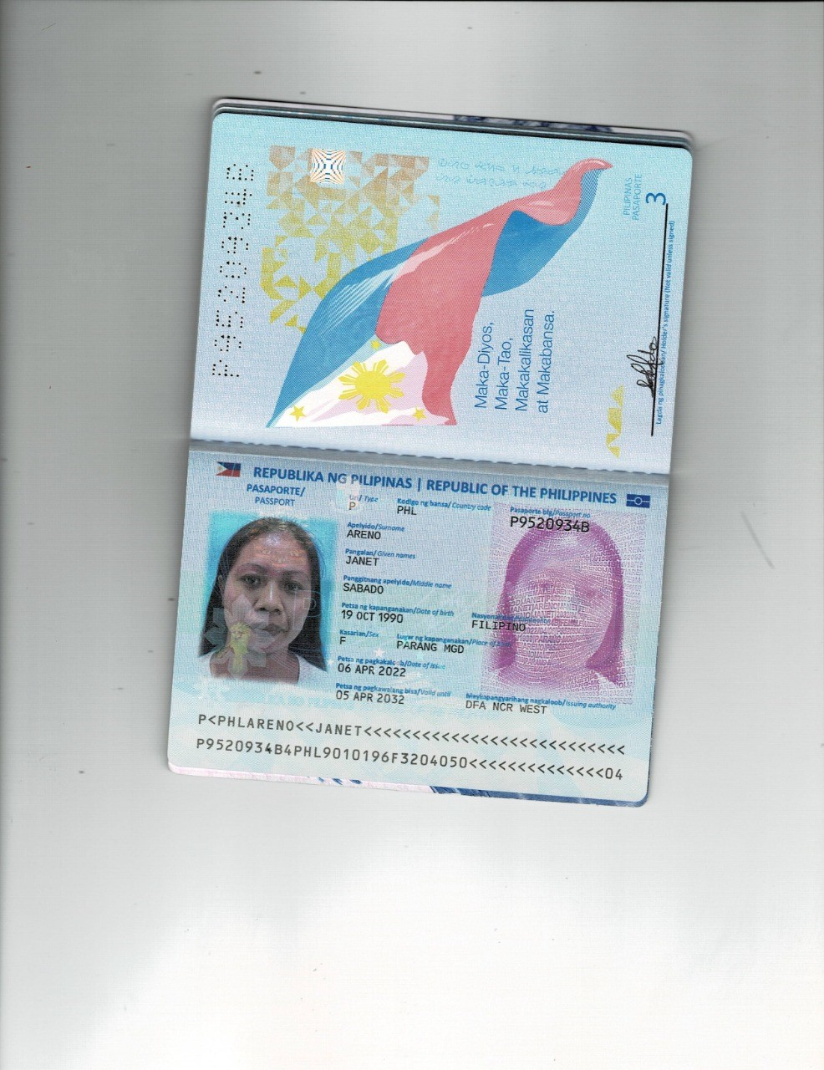PASSPORT