

REF. NO.:   |  | (FOR ARABIC REMARKS ONLY)  VACCINE: PFIZER 2nd DOSE ON FEB. 6, 2022  SHE IS ABLE TO TAKE CARE KIDS AND DO BABY SITTING  SHE CAN DO CLEANING, WASHING CLOTHES AND IRONING CLOTHES.  SHE ALSO KNOWS HOW TO COOK AND WILLING TO LEARN ARABIC COOKS.  SHE IS WILLING TO TAKE CARE DISABLE AND ELDERLY.
APPLIED FOR:
DOMESTIC HELPER
SALARY: $400
FULL NAME : PAZ TAGUBASE |  |  |  | DETAILS OF PASSPORT
NATIONALITY: FILIPINO |  |  | الجنسية | PASSPORT#:P8229129B | رقم الجواز
MOBILE NO. 09554083456 |  |  | رقم الهاتف | PLACE OF ISSUE:  DFA MANILA | مكانالأصدار
DATE OF BIRTH: MAY 22, 1977 |  |  | تاريخ الولادة | DATE OF ISSUE:  22 NOVEMBER 2021 | تاريخ الأصدار
AGE: 44 YEARS OLD  PLACE OF BIRTH :  VALENCIA BOHOL |  |  | العمر  مكان الميلاد | DATE OF EXPIRY:  21 NOVEMBER 2031 | تاريخ الأنتهاء
RELIGION: CHRISTIAN |  |  | الديانه | 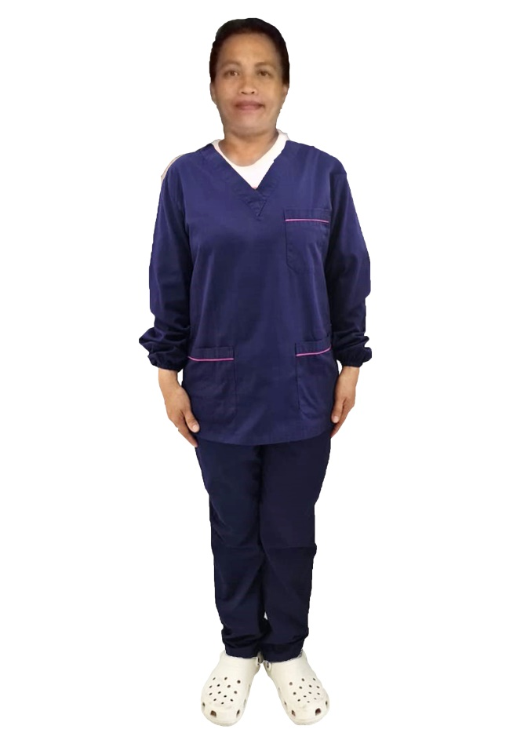
MARITAL STATUS:  MARRIED |  |  | الحالةالاجتماعية
WEIGHT: 57 KLS. |  |  | الوزن
HEIGHT: 4’11” |  |  | الطول
NO. OF CHILDREN: 6 |  |  | عدد الأطفال
PREVIOUS EMPLOYMENT ABROAD
الخبره السابقه للعمل
COUNTRY | POSITION |  | YEAR
 | FIRST TIMER
EDUCATIONAL QUALIFICATIONS
مستوى التعليم
HIGH SCHOOL GRADUATE
LANGUAGES
ARABIC | POOR
ENGLISH | FAIR
AL-DURRA CONTACT #

CLEAR PASSPORT COPY

