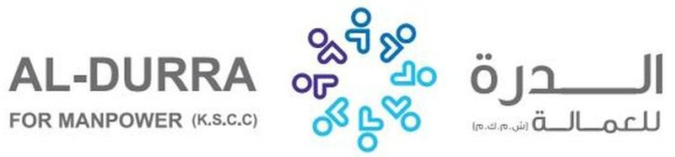

|  |  |  |  |  |  |
| --- | --- | --- | --- | --- | --- |
| REF. NO.: | | (FOR ARABIC REMARKS ONLY)  VACCINE: PFIZER  SHE IS WILLI TO DO BABY SITTING AND TAKING CARE OF KIDS.  SHE IS ABLE TO DO HOUSEHOLD CHORES SUCH AS; CLEANING, WASHING CLOTHES, AND IRONING OF CLOTHES.  SHE CAN COOK ARABIC FOOD.  SHE CAN DO GARDENING AND DECORATING.  SHE IS WILLING TO TAKE CARE ELDERLY. | | | |
|  | |  | | | |
| APPLIED FOR:  DOMESTIC HELPER | |
| SALARY: $400 | |
| FULL NAME : ELEVELYN BONIFACIO LAYCO | | | | DETAILS OF PASSPORT | |
| NATIONALITY: FILIPINO | | | الجنسية | PASSPORT# :P2048938B | رقم الجواز |
| MOBILE NO. 09958566696 | | | رقم الهاتف | PLACE OF ISSUE:  DFA NCR WEST | مكانالأصدار |
| DATE OF BIRTH: APRIL 25, 1982 | | | تاريخ الولادة | DATE OF ISSUE:  27 APRIL 2019 | تاريخ الأصدار |
| AGE: 39 YEARS OLD  PLACE OF BIRTH :  ZAMBOANGA CITY | | | العمر  مكان الميلاد | DATE OF EXPIRY:  26 APRIL 2029 | تاريخ الأنتهاء |
| RELIGION: CHRISTIAN | | | الديانه |  | |
| MARITAL STATUS: MARRIED | | | الحالةالاجتماعية |
| WEIGHT: 56 KLS. | | | الوزن |
| HEIGHT: 5’2’ | | | الطول |
| NO. OF CHILDREN: 3 | | | عدد الأطفال |
| PREVIOUS EMPLOYMENT ABROAD  الخبره السابقه للعمل | | | |
| COUNTRY | POSITION | | YEAR |
| KSA | DOMESTIC HELPER | | 2019-2021 |
|  |  | |  |
| EDUCATIONAL QUALIFICATIONS  مستوى التعليم | | | |
| COLLEGE GRADUATE | | | |
| LANGUAGES | | | |
| ARABIC | POOR | | |
| ENGLISH | FAIR | | |
| AL-DURRA CONTACT # | | | |

CLEAR PASSPORT COPY

