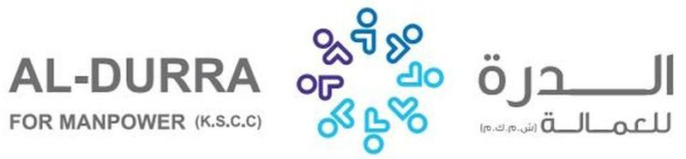

|  |  |  |  |  |  |
| --- | --- | --- | --- | --- | --- |
| REF. NO.: | | (FOR ARABIC REMARKS ONLY)  VACCINE: PFIZER FULL DOSE  SHE IS EX ABROAD IN SAUDI ARABIA FOR 4 YEARS  SHE CAN DO BABY SITTING AND TAKING CARE OF KIDS  SHE ALSO DO HOUSEHOLD CHORES SUCH AS CLEANING, WASHING CLOTHES, IRONING OF CLOTHES.  SHE ALSO CAN TAKE CARE OF ELDERLY AND CAN TAKE CARE OF DISABLE. | | | |
| C:\Users\Henry\Documents\Received Files\WhatsApp Image 2X2.jpg | |  | | | |
| APPLIED FOR:  DOMESTIC HELPER | |
| SALARY: $400 | |
| FULL NAME : SHERILL EGNISABAN ABUSTAN | | | | DETAILS OF PASSPORT | |
| NATIONALITY:FILIPINO | | | الجنسية | PASSPORT# :P6244029B | رقم الجواز |
| MOBILE NO. :0961935824 | | | رقم الهاتف | PLACE OF ISSUE:  PE RIYADH | مكانالأصدار |
| DATE OF BIRTH:  02 FEBRUARY 1976 | | | تاريخ الولادة | DATE OF ISSUE:  09 FEBRUARY 2021 | تاريخ الأصدار |
| AGE:45 YEARS OLD  PLACE OF BIRTH :  BAYBAY LEYTE | | | العمر  مكان الميلاد | DATE OF EXPIRY:  08 FEBRUARY 2031 | تاريخ الأنتهاء |
| RELIGION: CHRISTIAN | | | الديانه | C:\Users\Henry\Documents\Received Files\WhatsApp Image 2022-01-12 at 11.53.04 AM.jpeg | |
| MARITAL STATUS: MARRIED | | | الحالةالاجتماعية |
| WEIGHT: 70 KLS | | | الوزن |
| HEIGHT:5’1’ | | | الطول |
| NO. OF CHILDREN: 2 | | | عدد الأطفال |
| PREVIOUS EMPLOYMENT ABROAD  الخبره السابقه للعمل | | | |
| COUNTRY | POSITION | | YEAR |
| KSA | DOMESIC HELPER | | 2017-2021 |
|  |  | |  |
| EDUCATIONAL QUALIFICATIONS  مستوى التعليم | | | |
| HIGH SCHOOL GRADUATE | | | |
| LANGUAGES | | | |
| ARABIC | FAIR | | |
| ENGLISH | FAIR | | |
| AL-DURRA CONTACT # | | | |

CLEAR PASSPORT COPY

