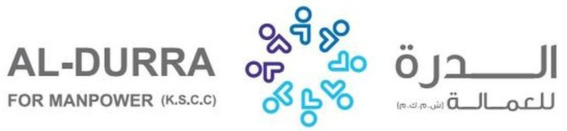

|  |  |  |  |  |  |
| --- | --- | --- | --- | --- | --- |
| REF. NO.: | | (FOR ARABIC REMARKS ONLY)  VACCINE: PFIZER FULL DOSE  SHE CAN DO BABY SITTING AND TAKING CARE OF KIDS  SHE ALSO DO HOUSEHOLD CHORES SUCH AS CLEANING, WASHING CLOTHES, IRONING OF CLOTHES.  SHE ALSO CAN TAKE CARE OF ELDERLY AND CAN TAKE CARE OF DISABLE. | | | |
| C:\Users\Henry\Downloads\270114301_291343576369519_5449613245376998523_n.jpg | |  | | | |
| APPLIED FOR:  DOMESTIC HELPER | |
| SALARY: $400 | |
| FULL NAME : ERLINDA ABEJO DAIGDIGAN | | | | DETAILS OF PASSPORT | |
| NATIONALITY:FILIPINO | | | الجنسية | PASSPORT# :P8014873B | رقم الجواز |
| MOBILE NO. :09169020400 | | | رقم الهاتف | PLACE OF ISSUE:  DFA MANILA | مكانالأصدار |
| DATE OF BIRTH:  17 DECEMBER 1989 | | | تاريخ الولادة | DATE OF ISSUE:  27 OCTOBER 2021 | تاريخ الأصدار |
| AGE:32 YEARS OLD  PLACE OF BIRTH :  JASAAN MISAMIS ORIENTAL | | | العمر  مكان الميلاد | DATE OF EXPIRY:  26 OCTOBER 2031 | تاريخ الأنتهاء |
| RELIGION: CHRISTIAN | | | الديانه |  | |
| MARITAL STATUS: SINGLE | | | الحالةالاجتماعية |
| WEIGHT: 61 KLS | | | الوزن |
| HEIGHT:5’2’ | | | الطول |
| NO. OF CHILDREN: 2 | | | عدد الأطفال |
| PREVIOUS EMPLOYMENT ABROAD  الخبره السابقه للعمل | | | |
| COUNTRY | POSITION | | YEAR |
|  |  | |  |
|  |  | |  |
| EDUCATIONAL QUALIFICATIONS  مستوى التعليم | | | |
| HIGH SCHOOL GRADUATE | | | |
| LANGUAGES | | | |
| ARABIC | POOR | | |
| ENGLISH | FAIR | | |
| AL-DURRA CONTACT # | | | |

CLEAR PASSPORT COPY

