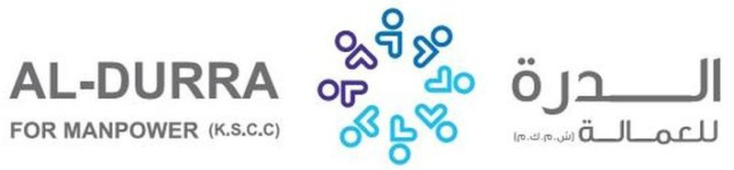

|  |  |  |  |  |  |
| --- | --- | --- | --- | --- | --- |
| REF. NO.: | | (FOR ARABIC REMARKS ONLY)  VACCINE: Pfizer fully vaccinated  SHE CAN DO BABY SITTING AND TAKING CARE OF KIDS.  SHE CAN ALSO DO WASHING CLOTHES, CLEANING AND IRONING CLOTHES.  SHE KNOWS HOW TO COOK ARABIC FOOD.  SHE CAN ALSO TAKING CARE OF KIDS. | | | |
|  | |  | | | |
| APPLIED FOR:  DOMESTIC HELPER | |
| SALARY: $400 | |
| FULL NAME : LANI ABUAN APURADO | | | | DETAILS OF PASSPORT | |
| NATIONALITY: FILIPINO | | | الجنسية | PASSPORT# :  P5449322B | رقم الجواز |
| MOBILE NO. : 09460060910 | | | رقم الهاتف | PLACE OF ISSUE:  PCG-DUBAI | مكانالأصدار |
| DATE OF BIRTH:  APRIL 22 , 1981 | | | تاريخ الولادة | DATE OF ISSUE:  AUG 27, 2020 | تاريخ الأصدار |
| AGE: 40  PLACE OF BIRTH :  UMINGAN PANGASINAN | | | العمر  مكان الميلاد | DATE OF EXPIRY:  AUG 26, 2030 | تاريخ الأنتهاء |
| RELIGION: CATHOLIC | | | الديانه |  | |
| MARITAL STATUS: SINGLE | | | الحالةالاجتماعية |
| WEIGHT: 56 KLS. | | | الوزن |
| HEIGHT: 5’1 | | | الطول |
| NO. OF CHILDREN: 4 | | | عدد الأطفال |
| PREVIOUS EMPLOYMENT ABROAD  الخبره السابقه للعمل | | | |
| COUNTRY | POSITION | | YEAR |
| K.S.A | DOMESTIC HELPER | | 2005-2010 |
| QATAR | DOMESTIC HELPER | | 2010-2012 |
| UAE | DOMESTIC HELPER | | 2015-2021 |
| EDUCATIONAL QUALIFICATIONS  مستوى التعليم | | | |
| HIGH SCHOOL GRADUATE | | | |
| LANGUAGES | | | |
| ARABIC | FAIR | | |
| ENGLISH | FAIR | | |
| AL-DURRA CONTACT # | | | |

CLEAR PASSPORT COPY

